GL Views Budget - Design Notes

Subject

Document History

|  |  |  |  |  |
| --- | --- | --- | --- | --- |
| **Version** | **Status** | **Author** | **Description** | **Date** |
| 0.1 | Issued | M Higginson | Initial Version | 05/11/2008 |
|  |  |  |  |  |
|  |  |  |  |  |
|  |  |  |  |  |
|  |  |  |  |  |
|  |  |  |  |  |
|  |  |  |  |  |

Distribution List

|  |
| --- |
| **Name** |
| Paul Swift Head of Development |
| Mark Roke Product Manager |
|  |
|  |
|  |

# 1.0 Bug Fix

Prior to extending the GL Views Tree the following bug should be fixed.

If you copy across part of the GL Structure the Inc Budget flag is not always set correctly.

It appears that there is a problem if you add a Control record and then edit it again to set the Inc Budget flag and then import the GL Codes, when the Inc Budget flag on the View Line record doesn’t get set and the Budgets are not copied across.

# 2.0 The GL Views Window

In v6.01 the GL Views Tree can display three additional columns, ‘Budget’, ‘Revised’ and ‘Variance’, on the right hand side of the tree if the GL Views Control record has the ‘Inc Budget’ flag ticked.

In order to make enough space for them to be visible we are going to insert a scroll box component to contain the column title and tree components, roughly covering the area shown by red box below:-

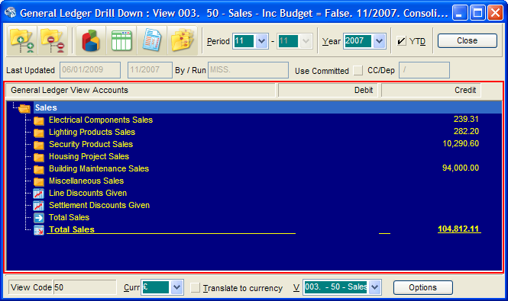

When we add the additional columns on the right hand side the scroll box will then show a horizontal scrollbar, the users can then choose to either use the scrollbar to scroll across to see them or make the form wider until they are visible.

In order to make space for the horizontal scrollbar we will shorten the tree control automatically to make vertical space for the scrollbar as required, this code will use the Windows API to identify the height of a horizontal scrollbar.

The Column Titles are panels which are completely independent of the tree control and need to be intelligently positioned by the Form Resize code.

## The Tree Control

The GL Views form uses an instance of TSBSOutlineB to display the tree of GL Codes and values.

In theory we only need to toggle the ShowValCol property between 2 and 5, depending in the Inc Budget flag on the View Control record, to display the new columns and setup appropriate column headers (with appropriate form resize code to move them around).

*NOTE: I said ‘In theory’ because although Eduardo wrote the mods to allow the Tree Control to support multiple columns I don’t know of any case where it has been used to display this many columns or a case where the number of columns dynamically changes, so it may not be 100% reliable.*

## Setting the Column Values

The data for the columns is provided in the OnNeedValue event handler which is called once per cell and uses properties on the control to identify the data needed and to return it back into the control.

This routine will need to be extended to handle the budget, revised and variance columns, the existing code in GL Views calls Profit_To_DateRange to calculate the balances, but after looking at how the OLE Server gets the balances I believe this code needs to call Total_Profit_To_Date instead which returns the Budget and Revised Budget as well as the Balance in one go.

Total_Profit_To_Date is in R&D\BTSupU1.Pas:-

Function Total_Profit_To_DateRange ( NType : Char;

NCode : Str20;

PCr,PYr,PPr,PPr2 : Byte;

Var Purch,

PSales,

PCleared,

PBudget,

PRBudget : Double;

Var BValue1,

BValue2 : Double;

Range : Boolean) : Double;

It returns the balance which maps onto either Debit or Credit depending on the sign, PBudget is the new ‘Budget’ column, PRBudget is the new ‘Revised’ column.

The ‘Variance’ column is a calculation:-

// If Revised Budget is set then use it to calculate the Variance

If (PRBudget <> 0.0) Then

Variance := Balance – PRBudget

Else

Variance := Balance – PBudget;